**EXPERIMENT 3 LINEAR RERESSION MODEL**

**AIM**

To develop a linear regression model for time series data

**PROCEDURE**

1. Import the necessary libraries:

import pandas as pd

import numpy as np

import matplotlib.pyplot as plt

import seaborn as sns

from sklearn.model_selection import train_test_split

from sklearn.linear_model import LinearRegression

from sklearn.metrics import mean_squared_error, r2_score

2. Load dataset

df = pd.read_csv('Toddler.csv')

3. Display basic statistics

print(df.describe())

4. Selecting features and target variable

X = df[['Age_Mons']]

y = df['Qchat-10-Score']

5. Split into training and testing sets

X_train, X_test, y_train, y_test = train_test_split(X, y, test_size=0.2, random_state=42, shuffle=True)

6. Train the Linear Regression model

model = LinearRegression()

model.fit(X_train, y_train)

7.Make predictions

y_pred = model.predict(X_test)

8.Evaluate the model

mse = mean_squared_error(y_test, y_pred)

r2 = r2_score(y_test, y_pred)

print(f"Mean Squared Error: {mse}")

print(f"R² Score: {r2}")



9.Visualizing the results

plt.figure(figsize=(10,5))

plt.scatter(X_test, y_test, color='blue', label='Actual')

plt.plot(X_test, y_pred, color='red', linewidth=2, label='Predicted')

plt.xlabel('Age in Months')

plt.ylabel('Qchat-10 Score')

plt.title('Linear Regression for Autism Screening Score by Age')

plt.legend()

plt.show()

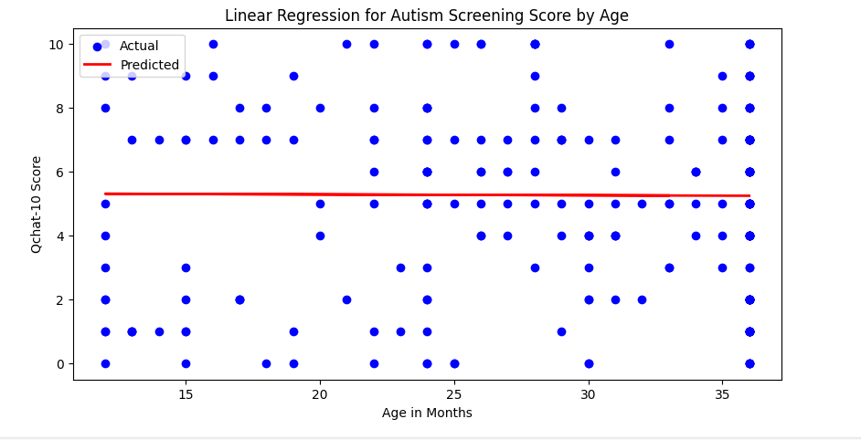

RESULT:

Thus the linear regression model for time series analysis on the autism dataset implemented successfully.